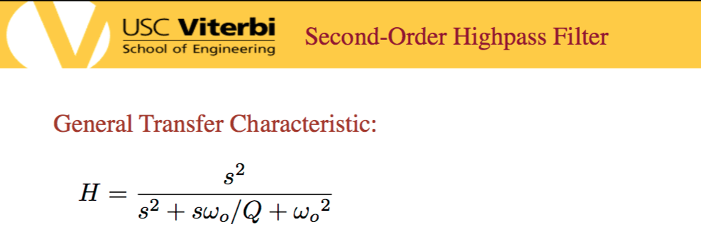

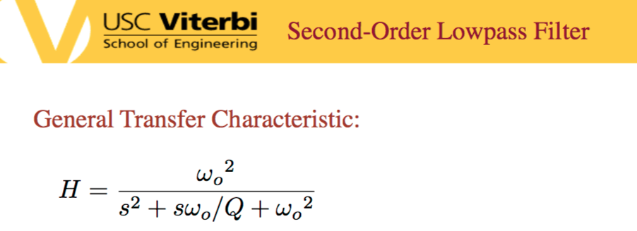

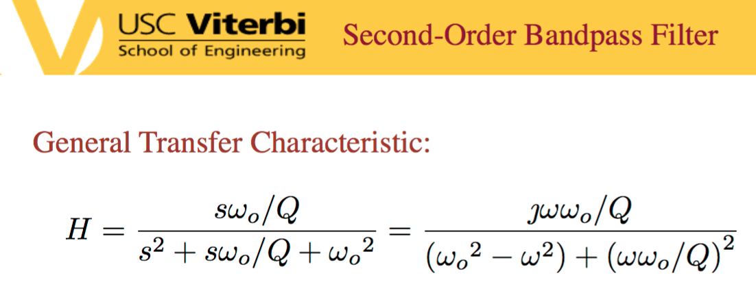

High Pass Inductor

Band Pass Resistor

Low Pass Capacitor

|  |  |  |
| --- | --- | --- |
|  | Low Frequency | High Frequency |
| Inductor | short | open |
| Capacitor | open | short |

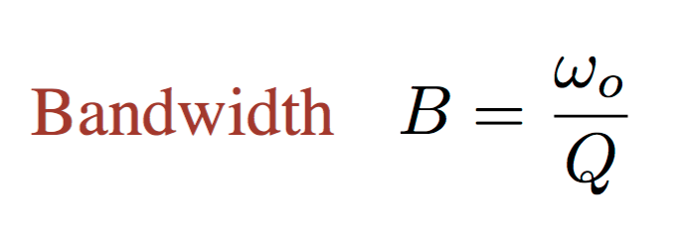

Cutoff frequency

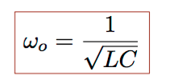

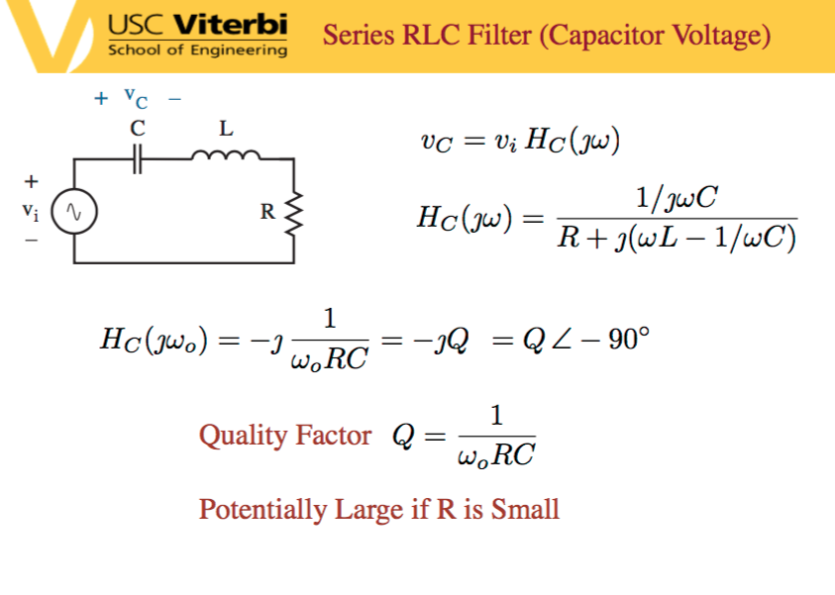

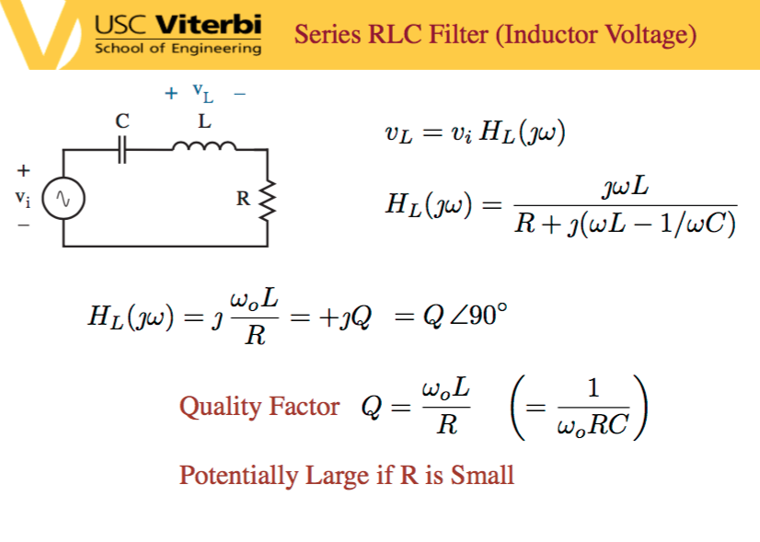

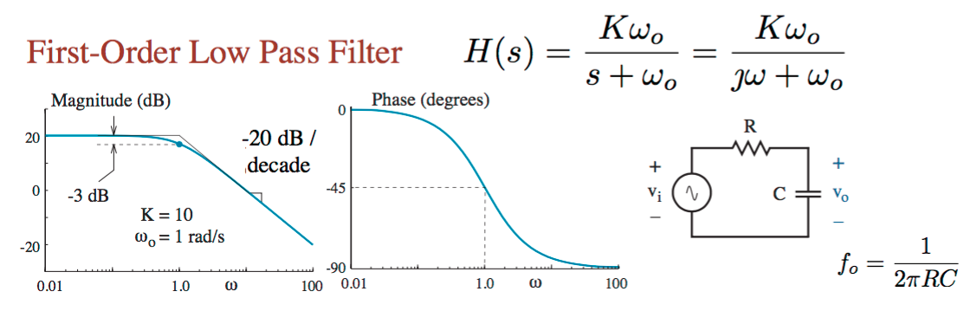

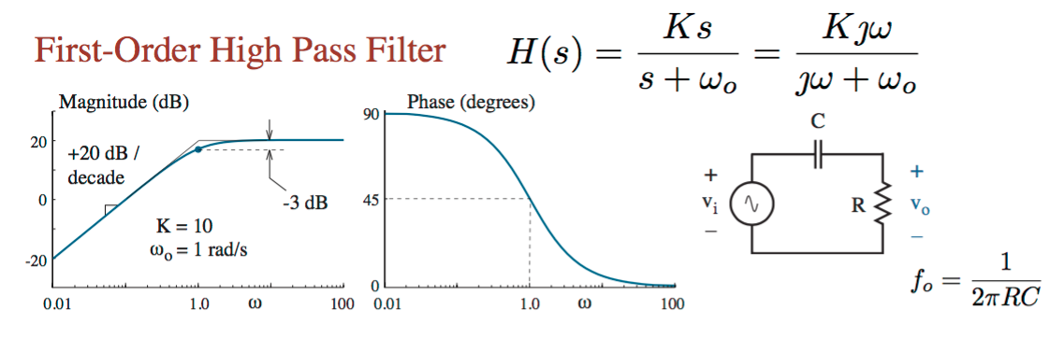

Laplace transform

Screen%20Shot%202015-12-12%20at%205.15.23%20PM.png

